CS 305 Module Two Coding Assignment

Instructions
Replace the bracketed text with the relevant information in your own words. If you choose to include images or supporting materials, make certain to insert them in all the relevant locations in the document.

Run Dependency Check

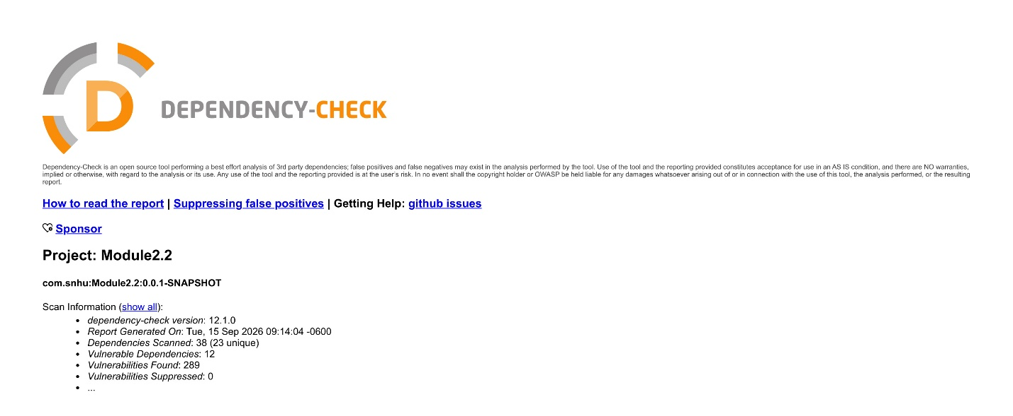

Document Results

The scan identified 12 vulnerable dependencies imported through the Spring Boot 2.2.4 web stack. Below are the identified dependencies, their highest severities, and descriptions:
- spring-core-5.2.3.RELEASE.jar
  - Highest Severity: CRITICAL (CVSS 9.8, known exploited)
  - Description: Core Spring container framework susceptible to remote code execution (RCE) through data binding parameter flaws and evaluation attacks.
- spring-web-5.2.3.RELEASE.jar
  - Highest Severity: CRITICAL (CVSS 9.8, known exploited)
  - Description: Web integration library vulnerable to remote code execution and denial-of-service conditions during HTTP request handling.
- spring-webmvc-5.2.3.RELEASE.jar
  - Highest Severity: CRITICAL (CVSS 9.8, known exploited)
  - Description: Model-View-Controller framework containing critical deserialization and class-loader access vulnerabilities.
- tomcat-embed-core-9.0.30.jar
  - Highest Severity: CRITICAL (CVSS 9.8, known exploited; 76 CVEs)
  - Description: Embedded Servlet container containing the Ghostcat AJP file read/inclusion vulnerability (CVE-2020-1938), HTTP/2 request smuggling, and remote denial-of-service flaws.
- tomcat-embed-websocket-9.0.30.jar
  - Highest Severity: CRITICAL (CVSS 9.8, known exploited; 77 CVEs)
  - Description: WebSocket extension engine sharing core Tomcat embedded vulnerabilities that permit denial-of-service and protocol bypasses.
- spring-boot-2.2.4.RELEASE.jar
  - Highest Severity: CRITICAL (CVSS 9.8; 9 CVEs)
  - Description: Spring Boot autoconfiguration and runtime parent subject to denial-of-service and temporary directory permission escalation.
- spring-boot-starter-web-2.2.4.RELEASE.jar
  - Highest Severity: CRITICAL (CVSS 9.8; 9 CVEs)
  - Description: Starter bundle referencing outdated, vulnerable versions of Tomcat, Spring Web, Jackson, and SnakeYAML.
- snakeyaml-1.25.jar
  - Highest Severity: CRITICAL (CVSS 9.8; 8 CVEs)
  - Description: YAML parser vulnerable to arbitrary code execution and memory exhaustion caused by untrusted object deserialization.
- jackson-databind-2.10.2.jar
  - Highest Severity: HIGH (CVSS 8.1; 11 CVEs)
  - Description: JSON data-binding library vulnerable to PolymorphicTypeValidator bypasses, XML external entity (XXE) expansion, and resource exhaustion from deeply nested JSON input.
- logback-core-1.2.3.jar
  - Highest Severity: HIGH (CVSS 7.5; 2 CVEs)
  - Description: Core logging utility subject to denial-of-service via deserialization in socket receiver components and RCE via untrusted JNDI/LDAP lookups.
- log4j-api-2.12.1.jar
  - Highest Severity: HIGH (CVSS 7.5; 5 CVEs)
  - Description: Logging interface impacted by improper output escaping in associated XML layouts and missing TLS hostname verification in socket appenders.
- hibernate-validator-6.0.18.Final.jar
  - Highest Severity: HIGH (CVSS 7.3; 4 CVEs)
  - Description: Bean validation engine susceptible to code injection and security bypasses through unsafe Expression Language (EL) evaluation in constraint messages

Analyze Results

- Update Spring Boot First: The main issue is that the project uses an old version of Spring Boot (2.2.4), which automatically pulls in outdated, unsafe libraries. Updating spring-boot-starter-parent in pom.xml to a modern, supported version is the easiest fix because it updates Tomcat, Spring Core, Jackson, and SnakeYAML all at once.
- Manually Update Old Libraries: If updating all of Spring Boot breaks the application, use the <properties> tag in pom.xml to manually update the most dangerous libraries individually (like upgrading Tomcat to fix the Ghostcat bug and Jackson to fix data security issues).
- Turn Off Risky Features: In the code and configuration, turn off unnecessary features like Jackson’s polymorphic type handling and avoid inserting raw user text into validation error messages.
- Catching False Alarms: Automated scanners often make mistakes by matching names incorrectly. For example, CVE-2025-15104 was flagged under Hibernate Validator, but the bug actually belongs to an unrelated HTML checker tool called validator.nu.
- Why False Positives Matter: Leaving false alarms in the report creates too much clutter, making it easy to miss real, dangerous security flaws like Spring4Shell.
- Protecting the Build Process: If an automated system is set to stop deployments whenever a vulnerability is found, false alarms will needlessly block working code from being released.
- Use a Suppression File: Verified false alarms should be hidden cleanly using a suppressions.xml file, targeted by the exact library hash or package name so real future risks aren't accidentally hidden.

